Actions for this week:
Report experimental results to my supervisor, address the issue of slow MultiRocket training on the RealWorld dataset, start designing a new model, add a recent state-of-the-art model as an additional baseline, look at the machine learning book recommended by my supervisor, explain how KNN, Random Forest and InceptionTime work and report this to my supervisor, show my supervisor the format of my project process, and start measuring the energy consumption of the six baseline models.

What did I do this week? Why did I do this?
1. Last week I reported the results of KNN, Random Forest and InceptionTime on the LARa dataset to my supervisor. This week I reported the remaining three baseline models – MiniRocket, MultiRocket and TST – on the LARa dataset.
2. I reported to my supervisor that I had read the machine learning book he recommended last week, and that I found it inspiring.
3. I completed the task my supervisor set last week: to explain in depth, with technical details, how KNN, Random Forest and InceptionTime work, and sent this explanation to my supervisor.
4. I showed my supervisor the format of my project process documentation and asked for his advice.
5. I addressed the issue of slow MultiRocket training on the RealWorld dataset.
6. I added a state-of-the-art model from the last two years as a new baseline and started designing my new model.
7. I started measuring the energy consumption of the six baseline models.

Why:
1. Last week I promised my supervisor that this week I would report the results of the other three baseline models, MiniRocket, MultiRocket and TST, on the LARa dataset. Once I finish training and testing all six baseline models on LARa, I will have completed the most basic, foundational work. This forms a strong baseline comparison for the new models I will design later.
2. My supervisor said that the writing style of this machine learning book is very friendly to non-experts. If I can use it as a reference, it may help me improve my previous problem of writing that is too dense and too complex.
3. This was a task my supervisor set for me last week, and he expected me to complete it this week. He also suggested that every time I finish an experiment, I should write a summary and a report. Moreover, explaining in depth, with technical details, all the models I use in my experiments is something I will have to do later in the dissertation anyway. By sending my draft to my supervisor early, he can give feedback on my writing style sooner, which helps me fix my long-standing issues of overly dense and overly complex writing more efficiently.
4. On 16 October, I asked my supervisor a question: the project process requires us to record detailed evidence of communication with the supervisor, and, where necessary, document how we adjust the project direction based on the supervisor’s suggestions, with evidence before and after the adjustment. We also need to record the detailed progress of the whole project. At that time I asked whether, given the volume of evidence, I could keep it on GitHub or OneDrive. My supervisor strongly agreed. Therefore I wanted to let him see my weekly project records early and give suggestions, so that I can do this part well in advance instead of rushing to整理 everything at the end of November.
5. Once I solve the slow training issue of MultiRocket on the RealWorld dataset, I will have completed training and testing of all six baseline models on both the RealWorld and LARa datasets. That means the foundational work before developing my new model will be finished.
6. By browsing journal and conference papers and checking other materials, I found that unless the core of my project is to compare representative baseline models from the past (for example traditional hand-crafted pipelines like KNN, or CNN-family models like InceptionTime), then I could possibly avoid adding a very recent state-of-the-art baseline. However, in my project the core contribution is to design a new model. That means I must compare it against the most advanced and effective models from the last couple of years. For example, if you design a fighter jet in 2025, it makes no sense to only compare it with fighter jets from the last century – that would not highlight its advantages.
7. In the human activity recognition field, model energy consumption is no less important than accuracy. We all know that if you only chase the highest accuracy, then the most complex and deepest models will usually perform best – just like in the LLM world with today’s generative AI. However, HAR has a key difference: the device is worn on the body, like a watch. If accuracy is high but energy consumption is also very high, the battery life will be short; in that case even the most accurate model is of limited practical value. In addition, many HAR papers currently do not report energy consumption. Therefore reporting energy makes my work significantly more valuable.

Outcomes and findings:
1. My supervisor asked me: “Have you written this experiment up?” I said: “Not yet, but I plan to write it up right after this meeting.” He replied: “Connect this work back to your research questions and explain how these results relate to your research questions.”
2. My supervisor does not recommend reading the whole book because it is too long, but he suggested that I can learn from its writing style.
3. My supervisor thinks what I wrote is good and at the right level, but I can explain more and in greater detail. He suggested that I first write as much as I need, and only then think about word count. In computer science, everyone’s experiments are different, so the amount of writing needed is also different. It is not like a journal article with a strict word limit.
4. My supervisor is satisfied with my current project process format. The only thing he asked me to add is: at the beginning of each weekly record document, I should list the “action items” for this week (the tasks to be done this week), and at the end I should write the “action items” for next week (the tasks I plan to complete next week).
5. I used almost every acceleration method available, and after seven hours I finally managed to let MultiRocket finish training one fold on the RealWorld dataset (there are 15 folds in total). However, this is still too slow: to train all 15 folds would require my laptop to run continuously for four days, which is a problem. Another issue is that a single Colab session has a maximum runtime limit of 24 hours. This is a drawback of Colab and makes it difficult to run very large, long-running projects.
6. I added rTsfNet as my new baseline model. This model was published in 2024, and its multi-head 3D rotation mechanism can explicitly handle sensor orientation. I first read this paper on 8 September (this is recorded in my “Week 0–1 (09.01–09.07)” document). Since 8 September I have been studying this model on and off, but I did not record all the detailed findings in my project progress notes. When I first trained and tested rTsfNet on the RealWorld dataset, the results were good: the LOSO macro F1 reached 0.8139, which is higher than all my previous baseline models. However, when I used exactly the same rTsfNet structure and hyperparameters on the LARa dataset, gradient explosion occurred. In the end, by adjusting rTsfNet’s learning rate, early stopping stage and other settings, I solved this problem.
7. I found a good way to build an energy proxy without needing specialised measurement equipment: provide an upper-bound estimate of energy per inference (mJ/inf) and plot accuracy–energy and accuracy–FLOPs Pareto-front curves. These are presented as proxy measurements, without claiming true on-device measurements. I construct a linear energy model:
E ≈α·FLOPs +β·Bytes +γ(in mJ).

Reflection:
1. What my supervisor said makes a lot of sense. After each experiment, I really should write down the results and findings in time, even if it is only a short note. If I leave it for too long, I will inevitably forget some details of the experiment, and trying to整理 everything at once later will be very troublesome. At the same time, writing a short summary and report after each experiment not only deepens my understanding of what I have done, but also helps me plan the next experiments in a more reasonable way.

2. I also agree that this book is indeed extremely long. For this book, I should only read the parts I actually need, and my main purpose should be to learn from its writing style. For example, I use the random forest model in my experiments, and this machine learning textbook also has a chapter on random forests. Later, when I explain how random forest works in my dissertation, I can refer to the way this book explains it and try to follow a similar, reader-friendly style.

3. Since my supervisor thinks my current piece of writing is good and at the right level, I will try to keep writing in this style in the future. At the same time, I also need to follow his suggestion to write more, and make the explanations fuller and more complete.

4. Following my supervisor’s advice, I have added “action items for this week” at the beginning and “action items for next week” at the end of each weekly project progress document. With these additions, the documents now look much clearer and easier to follow.

5. By comparing MiniRocket and MultiRocket on the LARa dataset, I found that MultiRocket’s overall performance is not as good as MiniRocket’s. Since these two models both belong to the Rocket family and their structures are quite similar, I can reasonably exclude MultiRocket from my set of baseline models and justify this choice in the dissertation. In addition, I have already added a new advanced model, rTsfNet, and successfully trained it, so dropping MultiRocket is even more reasonable. Being able to adjust my plan and resolve difficulties in this way should also count as a positive aspect of my problem-solving ability in an MSc project.

6. It is a pity that my original plan was to use the official GitHub source code for rTsfNet. However, the code kept throwing errors. After investigating in depth, I found that some of the libraries used in the official implementation of rTsfNet were too old. In machine learning, many libraries are constantly updated, so version conflicts between libraries happen very often. For example, once library A is upgraded, library B may no longer work with it; but if I downgrade A, it might then conflict with library C. After exploring different options, I finally decided to implement rTsfNet myself, aligning my implementation with the official model. This can be regarded as a contribution in its own right. Secondly, when researchers reproduce others’ models, journals and conferences do not require authors to use the original source code. In some cases, people also face serious version conflicts between libraries, so they implement the model from scratch and then release it using newer libraries, making it easier for other researchers to use. I think solving the gradient explosion problem is something that could also be written into the dissertation, and I will ask my supervisor next week whether this is appropriate. However, I have noticed that although rTsfNet achieves high accuracy on the RealWorld dataset, its performance on the LARa dataset is only average, roughly at the level of the mean performance of my six baseline models. I am not yet sure whether this is because my method for fixing gradient explosion is not ideal, or because rTsfNet itself is simply not well suited to LARa, given that the official paper did not test rTsfNet on LARa.

7. At first, I considered how I might measure the true energy consumption of the models using specialised hardware. Later I realised that in ML/HAR applications, many top conference papers evaluate efficiency using FLOPs, parameter counts and latency (on a unified hardware platform), or other proxy methods for estimating energy. These approaches are widely accepted, because not everyone has access to professional energy measurement equipment in a laboratory.

Have I finished this week’s action? What percentage? If not, how to improve?
Completion rate: 80%.
I still have the last part of measuring the energy consumption of the six baseline models left to complete.
The design of the new model is not yet finished.

Actions for next week:
Continue and complete the remaining part of measuring the energy consumption of the six baseline models. Think about how to design a new model based on rTsfNet and present the next set of experimental results to my supervisor. Ask my supervisor whether it is appropriate to include my solution to the gradient explosion problem in the dissertation.

Email records with supervisor Halloran – first email:
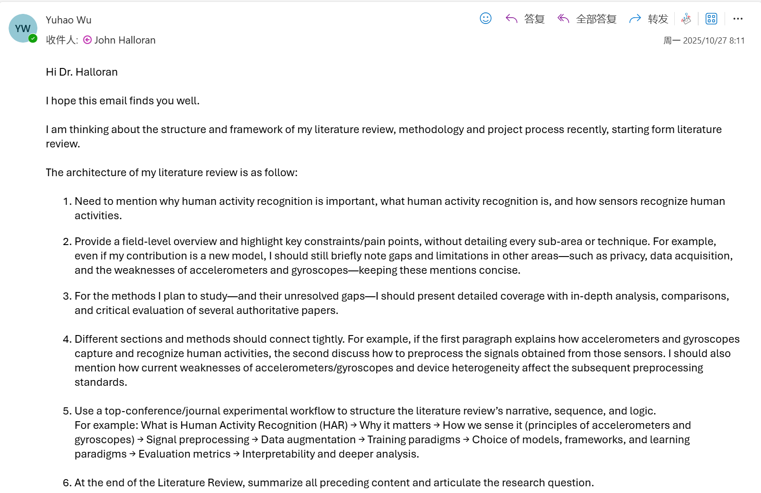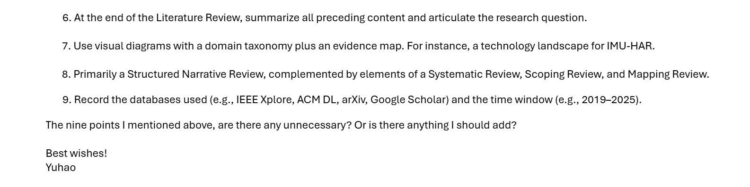

Supervisor’s replied:


Second email:
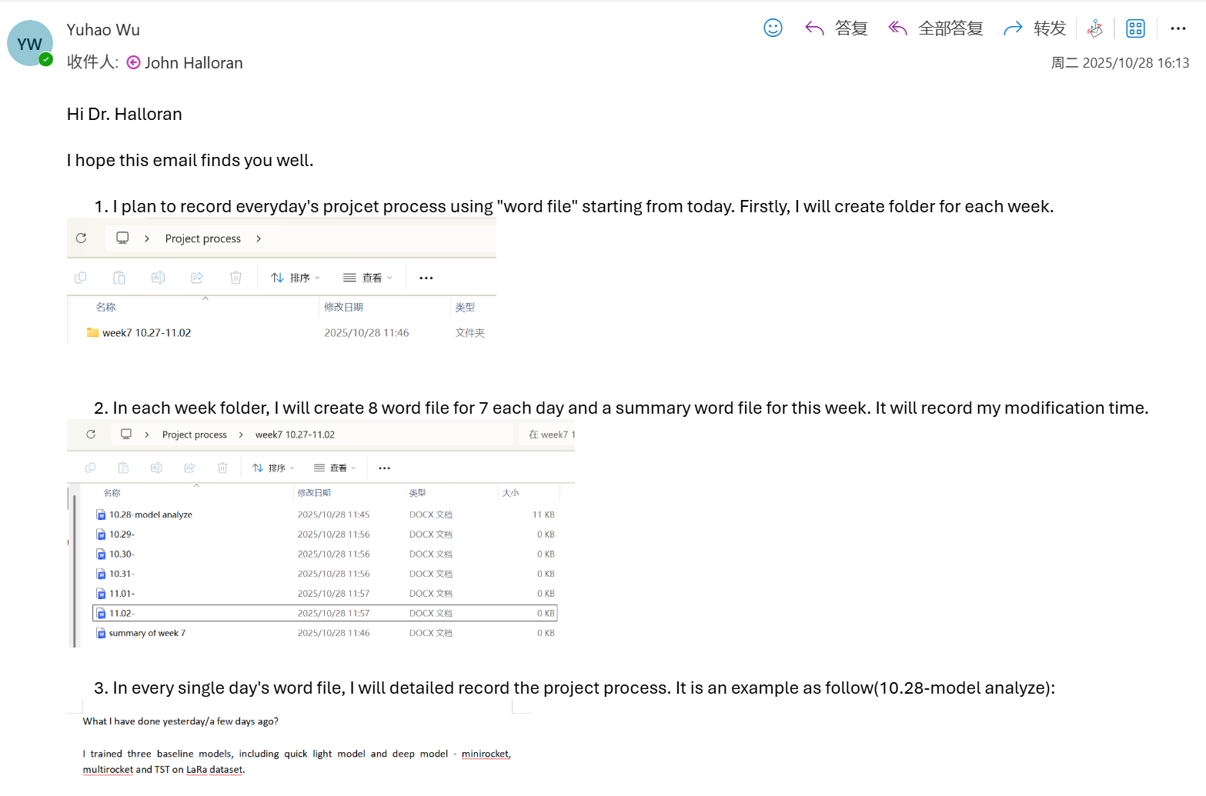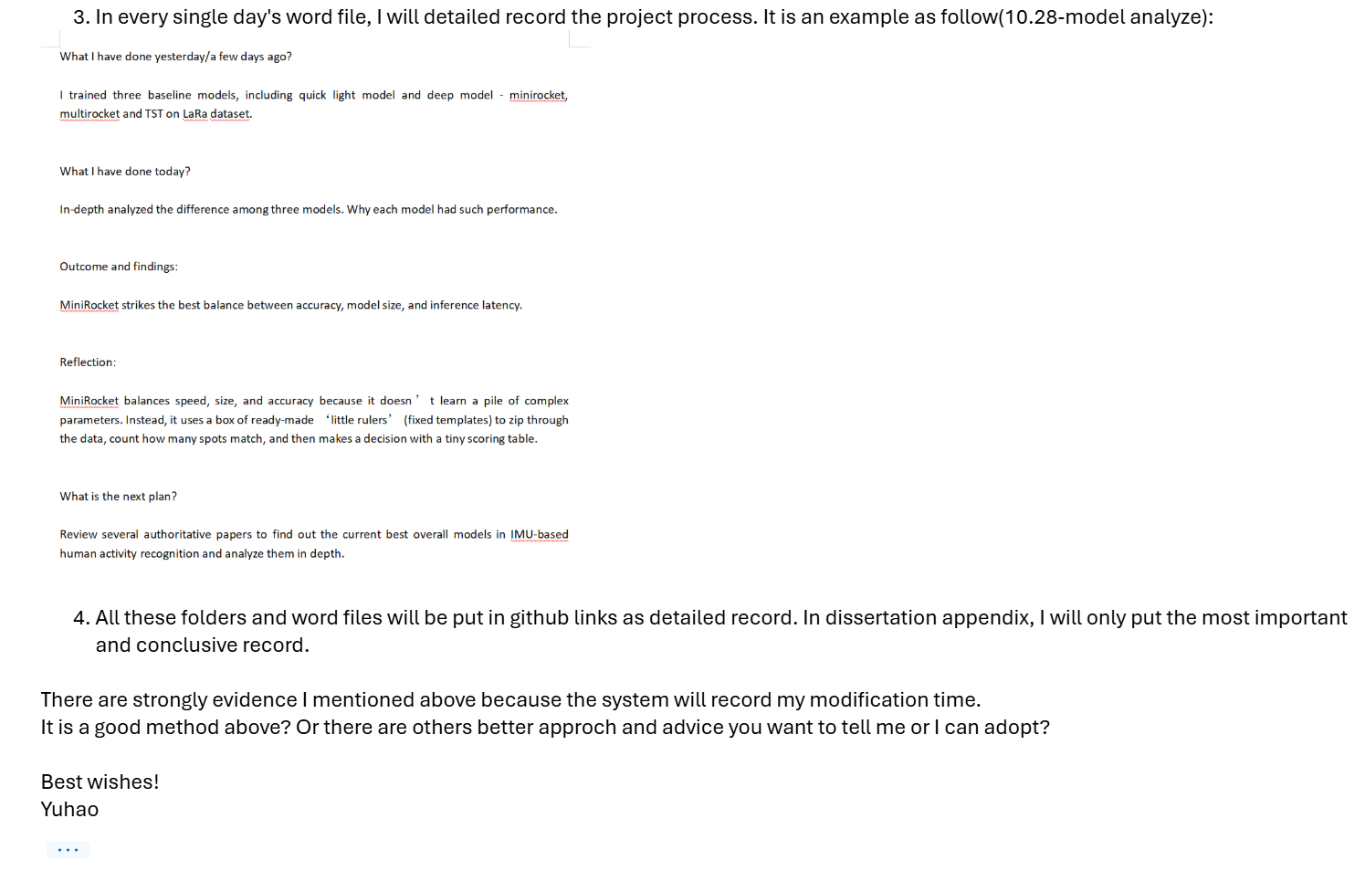
Because my supervisor was busy and didn’t reply to the second email, I showed it to him during this week’s meeting.

Meeting part:
I showed my supervisor, Dr Halloran, the performance of MiniRocket, MultiRocket and TST on the LARa dataset.
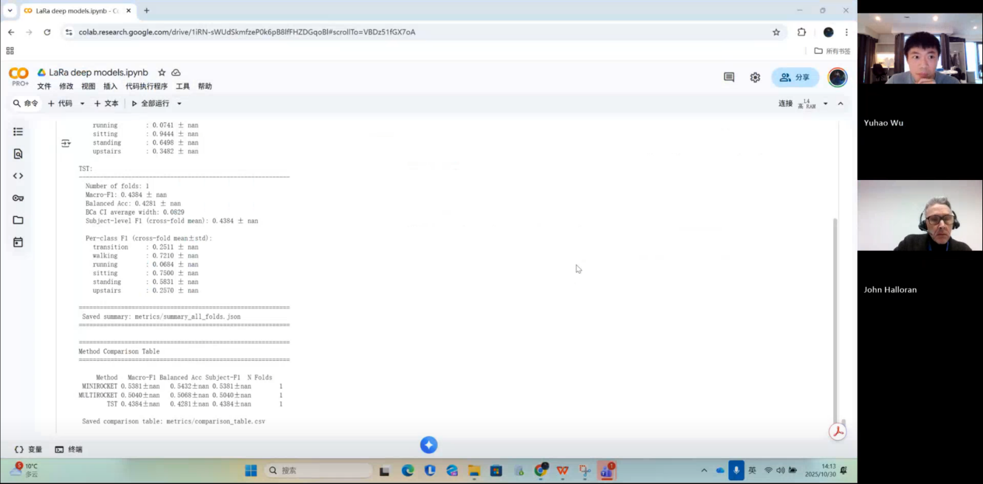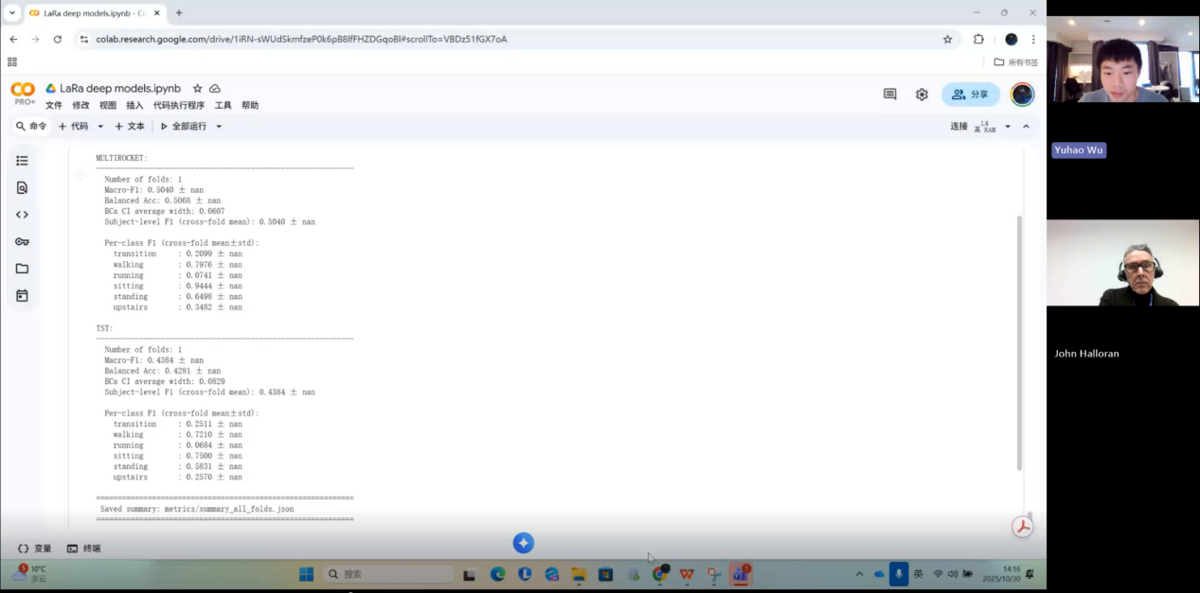
My supervisor’s response and suggestion were:
“Have you written up this experiment?”

My reply:
“No, not yet, but after this meeting I plan to write it up, including some details, results, and a few findings.”

My supervisor’s reply:
“Good. When you write the report, make sure you link this piece of work to your research question and talk about how these results relate to your research question. Many students often forget this step. You must always remember that the work you are doing is organised around a research question. Any experiment, any piece of primary research, has to explain how it helps you answer the research question, do you understand? How are these results related to the research question? So what will you do over the next week?”

My answer:
“I will finish and organise the training and testing results of these six models on the RealWorld dataset. If I can complete that, I might design some new models or make some improvements.”

My supervisor’s reply:
“Good. Yes, that’s great. Okay, so that will be your work for the coming week. It sounds like quite a lot. Can you manage it?”

My answer:
“Yes, because I have already completed the preprocessing for the RealWorld dataset.”

My supervisor’s reply:
“Excellent. Very good. Do you have any other questions for me?”

I also showed Dr Halloran my weekly project progress template.
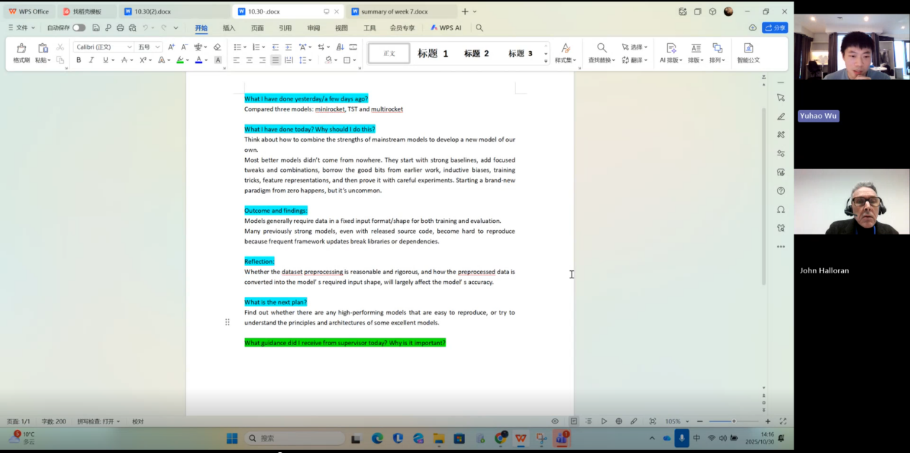
Me:
“I would like to record what I do every day, my plans, and a weekly summary about the progress of my project.”

My supervisor’s response and suggestion were:
“I think this is very good. You can turn it into a weekly template. I suggest you add one more element, which is ‘Actions’. You just need to add ‘Actions’ at the start of the document. You should have a section like ‘Agreed actions for this week’. That is for this particular week, do you see? Then you write down what you have done, then summarise what we discussed, and finally write the actions for the next week, okay? So the flow is: first, ‘I did the things we discussed’, then, ‘What I did and what I found’. Then in the supervision meeting we will discuss this and decide the actions for the following week. The key idea is ‘actions’. We define some actions for Week 5, and after you complete Week 5, we define actions for Week 6, and so on. Add this to your document. The format you have now already looks very good, and if you do this every week, it will be excellent.”

Me:
“Yes, this will take me some time every day.”

My supervisor’s reply:
“It is worth doing, because process accounts for 40% of the dissertation mark. I really like what you are doing now; just add the ‘Actions’ section, and use that word, okay? Anything else?”

I completed the task my supervisor set for me last week and presented it to him this week. The task was to explain in depth, with technical detail, how KNN, Random Forest and InceptionTime work.
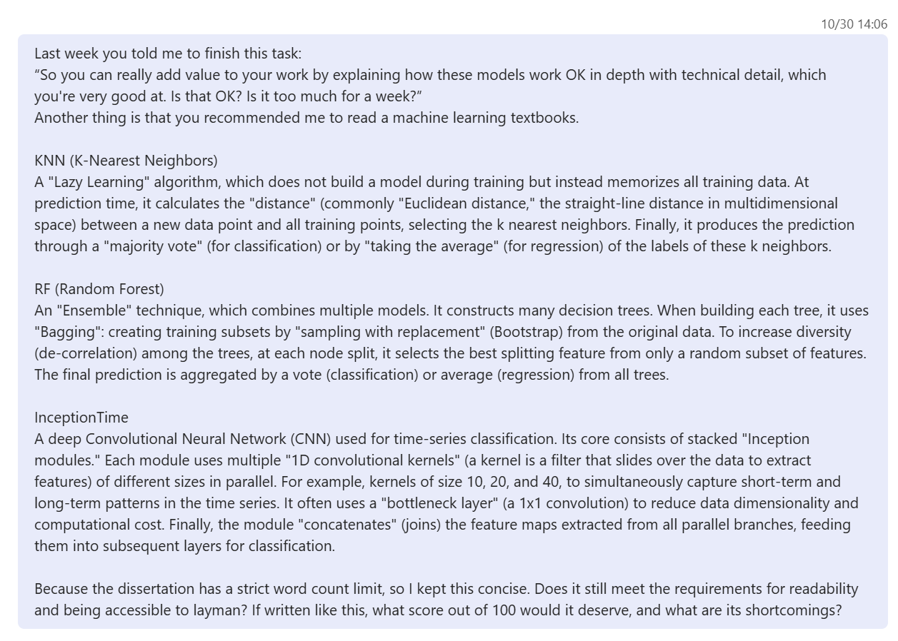

My supervisor’s reply:
I think you can go a step further on that basis and return even more to the fundamentals.
At nearest neighbors, relationship of data points, right. How they are mapped. And how the algorithm, and what it means. To say nearest neighbor, because that suggests distribution of data points. So we choose the nearest to the point that we are interested in, but that suggests a 2D space, where it could be a 3D space or a multidimensional space.
So if you can say a bit more about that.
Okay, and maybe put some diagrams.
The thing about a CNN, talk more about fundamentals of neural nets.
So that they consist of layers, the input is mapped to an input layer somehow that it’s propagated through a series of layers to an output layer.
You might talk about back propagation as part of training or other forms of training, just give basics on it,okay? And then how the CNN is different. Or more advanced than a basic neural net.
So we are got to CNN, random forest again, basics. So what is in an ensemble of?
Now don’t worry about, at this stage, don’t worry about the word limit.
Lots of people are concerned about word limits, but it’s more important at this point.
To write clearly and writes as much as you need. We will worry about word limits later.
Now, in computer science, word limits are not that important anyway. Because computer science writing, is about programming, about software of it’s about it’s a the writing is not about.
If you are doing history or English literature, writing is the product.
In computer science, the writing is not the prodect, the writing is about a product. So it depends how big that product is, how big is the software, how big is the analysis.
And then, of course, the writing has to get bigger.
So we don’t worry too much about marking, about word limits in computer science. So even if goes over, we are not going to reduce your mark.
Great, it’s nice, it’s good to have a piece of writing which is a. You know the length. That we recommend, but it’s not a problem. If it goes longer.
Okay, yes, so don’t worry about too much about that. Often students do amazing work and do a lots of work, so there is more to talk about. Yes, it’s second. And so don’t worry about that.
Yeah, this writing looks nice, I think you are finding the correct level.
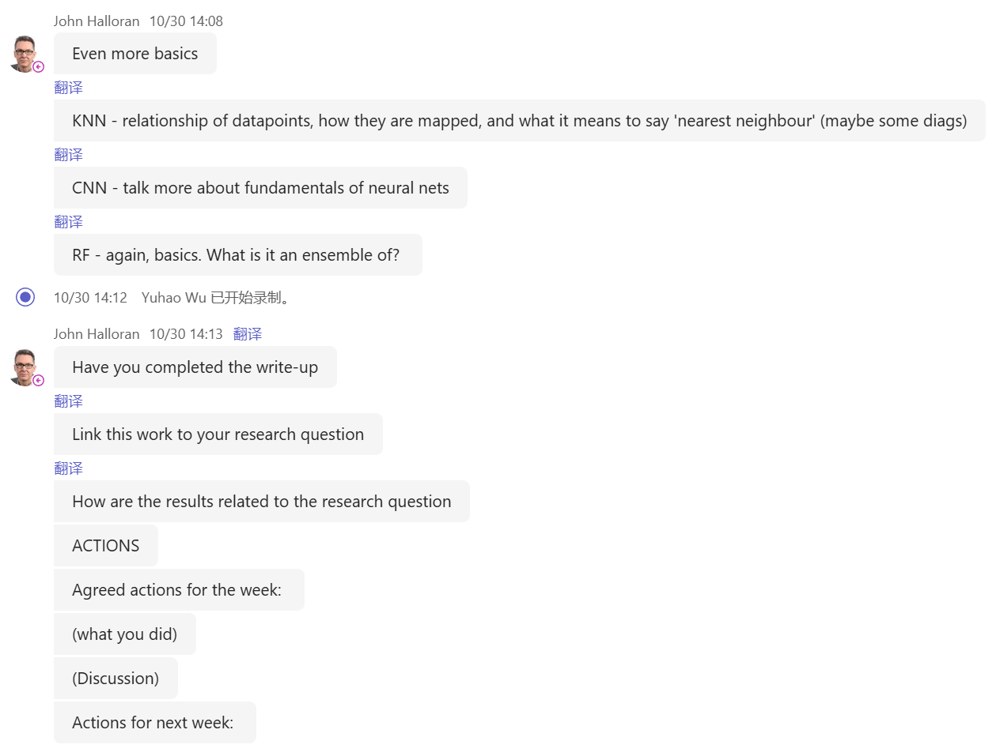

I asked my supervisor, John Halloran, two questions:
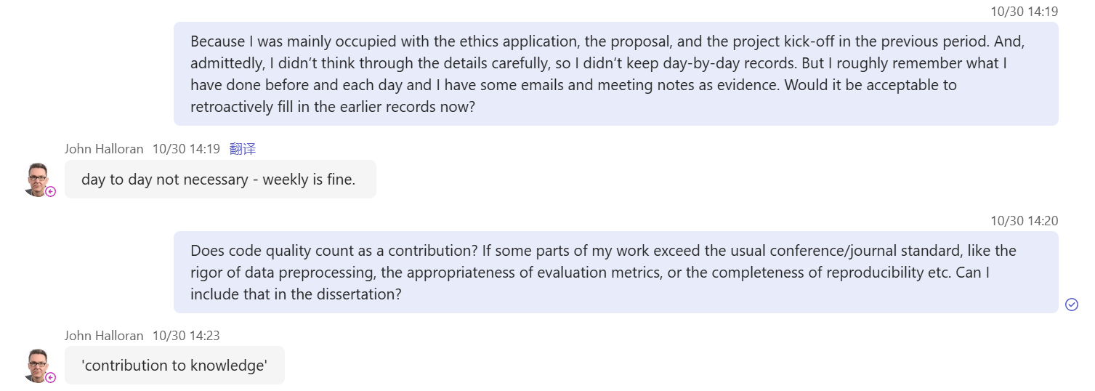
For Question 1, my supervisor’s answer was:
“You do not need to keep a day-by-day record. Daily records are not required. Weekly is enough. You showed me a document saying ‘what I did today’. You don’t need to write it by day. Weekly is fine, weekly is very good. Of course, you can still keep your own daily notes, but that would be a lot of work. I do not expect to see something every single day – usually a weekly format is perfectly good. So don’t worry if the early progress seems slow. Talk about what you did for writing the proposal, what you did for the ethics application, how you decided on the topic, why you chose this topic, and why it is interesting to you. Make these things clear, and indicate that they happened in the early stage of the project – that is enough, no problem. It is not an issue if there are not many details at the beginning.”

Me:
“Yes, I have been doing these things.”

Question 2:
Me:
“Can the quality of my code be counted as a contribution in the dissertation?”

My supervisor’s answer to Question 2 was:
“Yes, it is important. The technical quality of your work is very important – the technical part of your work counts for 30%.
If you have robust, maintainable code, you can open-source it as a public repository, ideally with documentation.
This is a very strong thing to do; it shows that you are willing to contribute your code to the world.
You are letting others explore and improve it – that is exactly what research is about: we make our research outputs available so that others can build on them. And if you plan to write a journal or conference paper, this is now very important.
These days, when you submit a paper, providing code and data has become standard practice, so there is usually a link in the paper to a code repository. So yes, all of this is very important. Code quality is important, professionalism is important, and complete documentation is also important. You can even reuse the documentation in your report: in the dissertation you can show ‘this is my code repository, this is its structure, here is the documentation, and I am contributing it to future researchers’. This is a very good practice, really excellent.
Yes, so the answer is definitely yes.”

Me:
“That’s all my questions.”

Supervisor:
“Yes, you are talking about ‘contribution’. There is a type of contribution called ‘research contribution’, also known as ‘contribution to knowledge’. That is what research means: contribution to knowledge. We extend what is known; that is the purpose of academic research. Of course, there are other types of contribution as well. Another type is the contribution of ‘technical resources’. If you provide technical resources to support other researchers, your contribution to knowledge becomes stronger. In other words, the technical work underpins the research contribution.
So yes, this is important – it is a contribution in its own right. Code quality is a form of contribution because it helps others to use and further develop your research.”

Important points from my supervisor John Halloran:

Research and writing principles
When writing experiment reports (write-ups), always tightly link the work to the Research Question (RQ).
Clearly answer: “How do these results relate to the research question?”
Every experiment or piece of primary research must explain how it helps to answer the research question.
My supervisor stressed that “many students forget to do this step”, so I need to pay special attention.
Always remember: everything I do is organised around one research question or a set of research questions.

Process recording and weekly report format
Weekly records are sufficient: there is no need to keep daily records. Daily notes can be kept for myself, but they are not the expected standard format and create a lot of extra work.
My supervisor approves of my current document format and suggested turning it into a weekly template.
He suggested adding “Actions” and putting “Agreed actions for the week” at the beginning of the document.
Recommended weekly report structure:

* Agreed actions (agreed actions for this week)
* What I did & findings – “I completed the things we discussed; here is what I did and what I found”
* Supervision discussion (key points from the supervision meeting)
* Actions for next week

My supervisor agreed with my work plan for the coming week but reminded me that the workload looks quite heavy and asked whether I can manage it.

Marking and process requirements
Process accounts for 40% of the total dissertation mark. Therefore, keeping weekly records and clearly defined action items is “well worth doing”.
The technical component accounts for 30%. Technical quality is very important.

Early-stage materials and “slow start”
There is no need to worry about “not much detail at the beginning” or a “slow start”.
My supervisor suggested clearly writing down what I did in the early stage of the project, such as:

* How I produced the proposal
* How I completed the ethics application
* How I defined the research topic, why I chose it, and why it is meaningful or interesting to me
It is enough to explain that these things happened at the start of the project; it does not matter if there are not many fine details.

Code, documentation and “contribution to knowledge”
Code quality, professionalism and full documentation are all very important.
I can reuse the documentation in my report or dissertation, and explicitly show the repository in the thesis:

“This is my repository, this is its structure and documentation, and I am making it available for future researchers.” – This is a very good practice.

For robust, maintainable code, my supervisor recommends a public/open-source repository with documentation:

* This shows I am willing to contribute my code to the community, so others can explore and further develop it.
* Nowadays, when submitting journal or conference papers, providing code and data is usually required, and the paper normally includes a link to the repository.

My supervisor distinguished two types of contribution:

* Contribution to knowledge – the core purpose of academic research.
* Contribution of technical resources – open-source code, data, tools, etc.

Technical work strengthens my “contribution to knowledge”, because it supports other researchers in reproducing and extending my work.
Therefore, code quality itself is also a form of contribution, because it helps others to use and build on my research.

